Credit Card Customer Churn Prediction and Data-Driven Retention Strategies Using Machine Learning and Explainable AI
Credit Churn Intelligence
Author: Apeksha Bhushan
Program: IBM SkillsBuild Data Analytics with AI Academic Internship
Dataset: Credit Card Customers — Kaggle (Sakshi Goyal) (https://www.kaggle.com/datasets/sakshigoyal7/credit-card-customers)
Model: XGBoost | Test ROC-AUC: 0.9932 | Test F1: 0.9136
Executive Summary
This report presents a complete, end-to-end machine learning pipeline for predicting credit card customer churn and generating data-driven retention recommendations. The project — Credit Churn Intelligence — was developed as part of the IBM SkillsBuild Data Analytics with AI Academic Internship.
The final XGBoost model achieves a test ROC-AUC of 0.9932 and F1-score of 0.9136, correctly identifying 91.1% of at-risk customers while maintaining a precision of 91.6%. SHAP (SHapley Additive exPlanations) analysis reveals that transaction activity, declining engagement trends, and inactivity duration are the most influential factors in the model predictions. A professional, interactive Streamlit dashboard delivers these insights to business users across five pages.
Key results: 1,615 customers identified as High Risk (15.9% of portfolio); average predicted churn probability 7.9%; top risk factor is low transaction count.
1. Introduction
Customer attrition — the process by which customers discontinue their relationship with a financial institution — represents a significant and measurable business risk. In the credit card industry, acquiring a new customer costs substantially more than retaining an existing one. Early identification of at-risk customers enables targeted, cost-effective interventions before attrition occurs.
This project addresses this challenge by building an AI-powered customer intelligence system that combines robust machine learning prediction with transparent, explainable AI and a rule-based retention recommendation engine. The system is delivered as a Streamlit interactive dashboard, making it accessible to both technical and business stakeholders.
2. Business Problem
A credit card business needs to identify customers who are likely to close their accounts or reduce card usage significantly. The business questions addressed in this project are:
- 1. Which customers are most likely to churn in the near term?
- 2. What behavioural and demographic patterns are associated with attrition risk?
- 3. How can the business prioritise and personalise retention interventions?
- 4. What data-driven actions are most appropriate per customer segment?
3. Project Objectives
The project pursues the following measurable objectives:
- Build a leakage-free, reproducible machine learning pipeline for binary churn classification.
- Achieve strong discriminative performance (target: ROC-AUC > 0.95).
- Provide transparent, customer-level predictions via SHAP Explainable AI.
- Segment customers by risk tier and generate personalised retention recommendations.
- Deliver an interactive Streamlit dashboard for business users.
4. Dataset Description
The dataset is sourced from Kaggle (Credit Card Customers by Sakshi Goyal) and contains 10,127 credit card customers with 23 columns covering demographics, product details, engagement metrics, financial behaviour, and transaction activity.
Dataset Statistics:
Property | Value
Total Customers | 10,127
Attrited Customers | 1,627 (16.1%)
Existing Customers | 8,500 (83.9%)
Total Features (raw) | 23 columns
Missing Values | None
Dataset Source | Kaggle — Credit Card Customers (Sakshi Goyal)
4.1 Feature Groups
- Demographic: Customer_Age, Gender, Dependent count, Education Level, Marital_Status, Income_Category
- Product / Relationship: Card_Category, Months_on_book, Total_Relationship_Count
- Engagement: Months_Inactive_12_mon, Contacts_Count_12_mon
- Financial / Credit: Credit_Limit, Total_Revolving_Bal, Avg_Open_To_Buy, Avg_Utilization_Ratio
- Transaction Behaviour: Total_Trans_Amt, Total_Trans_Ct, Total_Amt_Chng_Q4_Q1, Total_Ct_Chng_Q4_Q1
4.2 Excluded Columns — Data Leakage
Two columns beginning with 'Naive_Bayes_Classifier_Attrition_Flag_...' were detected and excluded from all modelling. These are pre-computed Naive Bayes classifier probabilities derived directly from the target variable (Attrition_Flag). Including them would constitute target leakage — inflating model performance without any genuine predictive signal. They were excluded from feature sets, SHAP analysis, and the Streamlit prediction form. The identifier column CLIENTNUM was also excluded as a model feature.
5. Data Quality Assessment
A comprehensive data quality audit was performed before any modelling. Results:
- Missing Values: None (0 missing values across all 23 columns)
- Duplicate Rows: None
- Duplicate Customer IDs (CLIENTNUM): None
- Class Imbalance: Present — 83.9% Existing Customers, 16.1% Attrited Customers
- Leakage Columns: 2 detected and excluded (Naive Bayes classifier probability columns)
No destructive cleaning was performed. The dataset was clean and complete. The class imbalance was addressed through model-level weighting (class_weight='balanced' for Logistic Regression and Random Forest; scale_pos_weight for XGBoost) and threshold optimisation on validation data.
6. Data Preprocessing
A leakage-safe preprocessing architecture was implemented using scikit-learn's Pipeline and Column Transformer:
- Numerical features (21): StandardScaler — zero mean, unit variance
- Categorical features (6): OneHotEncoder with handle_unknown='ignore'
Critical principle: The Column Transformer was fitted ONLY on training data (X_train). Test data was transformed using parameters from the training-fitted preprocessor, preventing any data leakage from test statistics into the model.
Target encoding: Attrition_Flag was mapped to a binary integer column (Churn): Existing Customer = 0, Attrited Customer = 1.
7. Exploratory Data Analysis
EDA was performed to understand the distribution of features and their relationship with attrition. Key findings:
- Transaction Activity: Attrited customers show significantly lower transaction counts (median ~34 vs ~68 for existing customers). This is the single strongest observable differentiator.
- Transaction Trends: The Q4/Q1 ratios for both transaction count (Total_Ct_Chng_Q4_Q1) and amount (Total_Amt_Chng_Q4_Q1) are substantially lower for attrited customers, indicating that declining usage precedes attrition.
- Inactivity: Attrited customers average 2.7 months inactive vs 2.3 months for existing customers. Three or more months of inactivity is associated with elevated risk.
- Contact Frequency: Attrited customers have slightly higher average contact counts (2.6 vs 2.4), possibly indicating unresolved service friction.
- Card Category: Gold and Platinum cardholders show higher churn rates than Blue cardholders, suggesting unmet expectations among premium segments.
- Demographics: Age, gender, and income category show limited statistical association with churn compared to behavioural variables.
Statistical Analysis: Mann-Whitney U tests confirmed statistically significant differences (p < 0.001) between existing and attrited customers for all key numerical variables. Chi-square tests confirmed statistically significant associations for Card_Category, Marital_Status, and Income_Category.
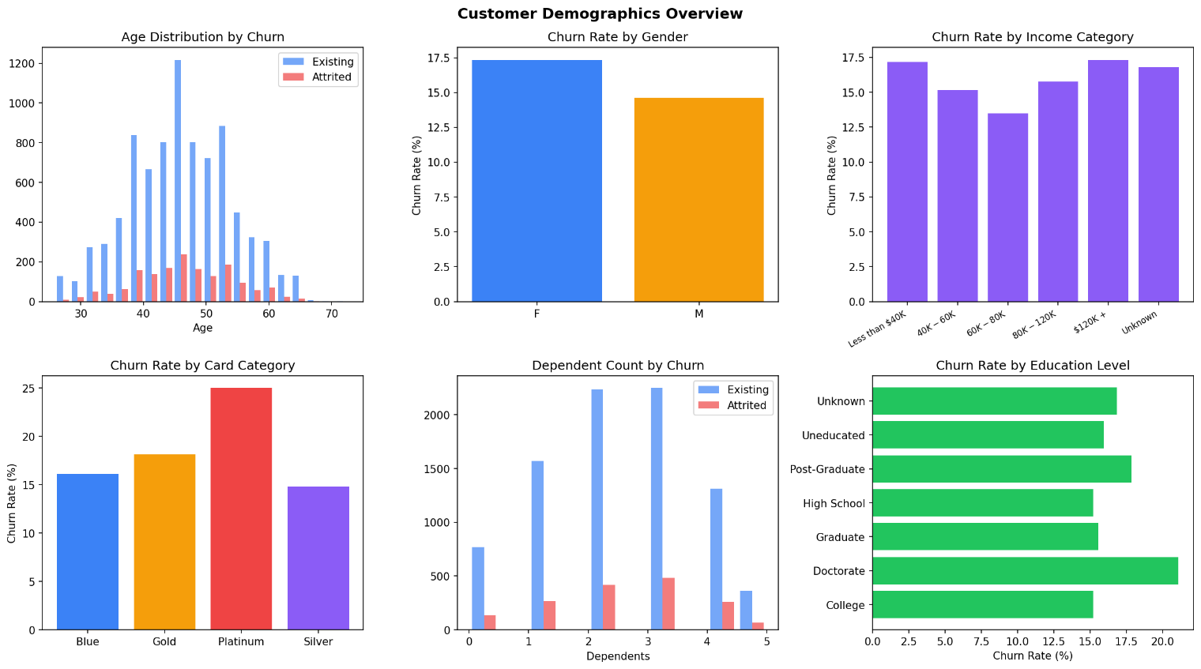
Figure 1: Customer Demographics — Age, Gender, Income, Card Category, and Education distributions by churn status.

8. Feature Engineering
Figure 2: Transaction and Engagement Behaviour — six key variables compared between Existing and Attrited customers.
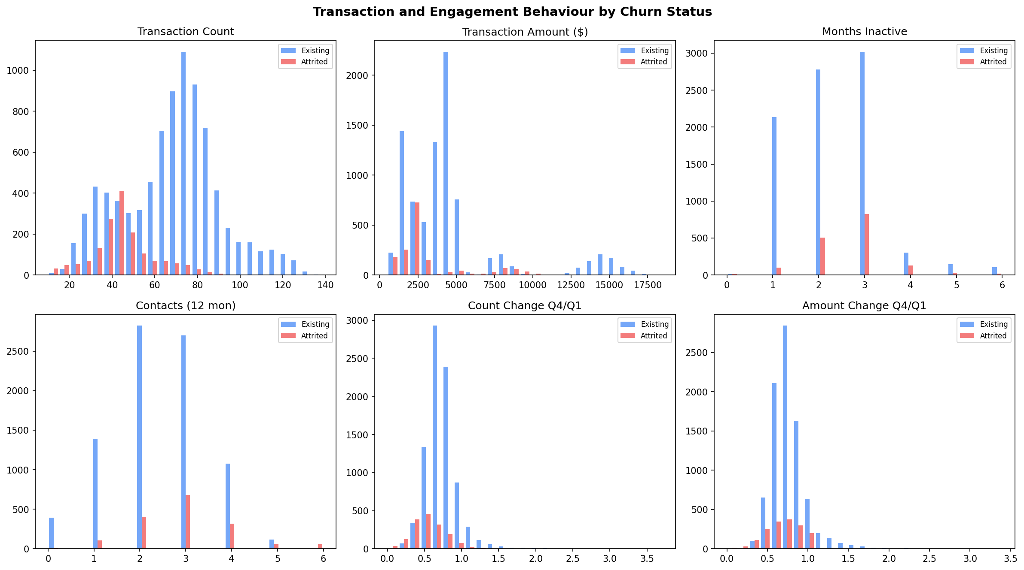
Eight domain-informed features were engineered to capture business-relevant signals not fully represented by the raw columns:
Figure 3: Financial Behaviour — Credit Limit, Revolving Balance, and Utilisation Ratio distributions by churn status.
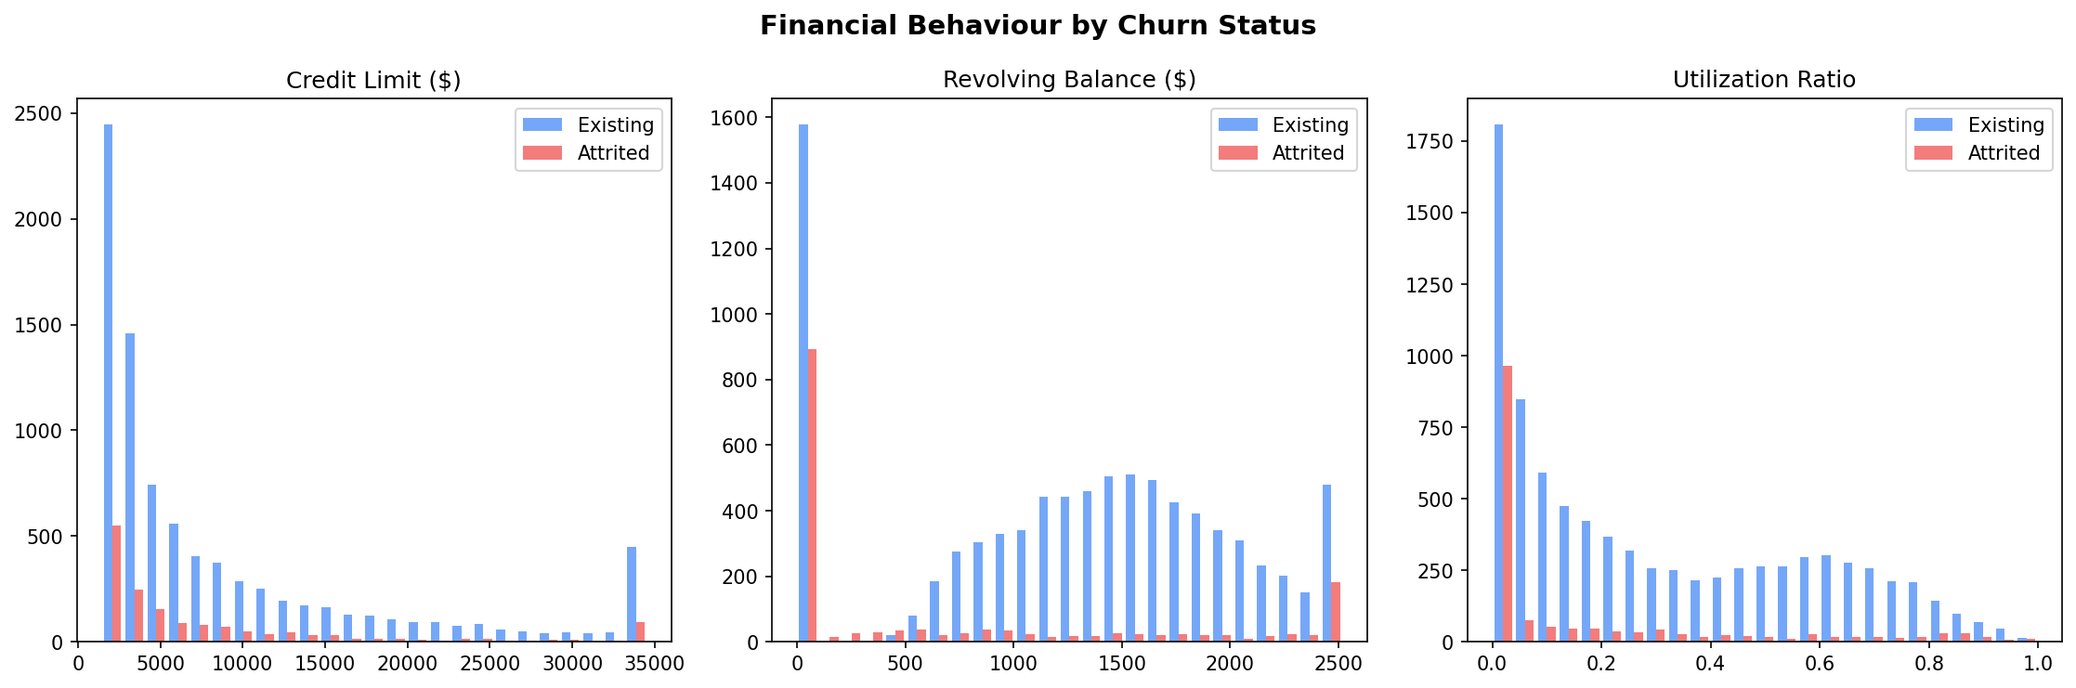
- Avg_Trans_Value — Average transaction amount (Total_Trans_Amt / Total_Trans_Ct): proxy for spending intensity
- Is_Inactive — Binary flag: 3+ months inactive in last 12 months
- Is_High_Contact — Binary flag: 4+ bank contacts in last 12 months
- Is_Low_Trans — Binary flag: fewer than 40 transactions in last 12 months
- Zero_Revolving_Bal — Binary flag: no revolving balance (possible disengagement signal)
- Trans_Change_Score — Combined Q4/Q1 change signal (Amt_Chng × Ct_Chng)
- Low_Relationship — Binary flag: 2 or fewer banking products
- Age_Group — Coarse customer age segment for interpretability

9. Machine Learning Methodology
9.1 Train / Test Split
A stratified random split was used (80% training, 20% test) with a fixed random seed (42) for reproducibility. Stratification preserves the class ratio in both sets. The test set was kept strictly untouched until final evaluation — it was not used for cross-validation, threshold optimisation, or any other model selection decision.
Training: 8,101 samples (16.1% churn) | Test: 2,026 samples (16.0% churn)
9.2 Class Imbalance Strategy
The dataset has a 16.1% attrition rate, creating a class imbalance that makes raw accuracy a misleading metric. The strategy employed was: (1) class_weight='balanced' for Logistic Regression and Random Forest; (2) scale_pos_weight≈5 for XGBoost; (3) threshold optimisation on validation data rather than using the default 0.5 threshold; (4) emphasis on ROC-AUC, PR-AUC, recall, and F1 over accuracy. SMOTE was not used as class weighting achieved strong results without modifying the training distribution.
10. Model Development
Three models were developed to demonstrate a progression from interpretable linear baseline to gradient boosting:
- Logistic Regression — Interpretable linear baseline with L2 regularisation (C=0.1), class_weight='balanced'
- Random Forest — Bagging ensemble with 300 trees, max_depth=10, class_weight='balanced'
- XGBoost — Gradient boosting with 300 estimators, learning_rate=0.05, scale_pos_weight=5
Model performance was evaluated initially using 5-fold stratified cross-validation on the training set (out-of-fold predictions). All models were then trained on the full training set and evaluated on the held-out test set.
11. Model Evaluation
All models were evaluated on the held-out test set using a full suite of metrics. The following table presents the results:
Model | Accuracy | Precision | Recall | F1 | ROC-AUC | PR-AUC
XGBoost (Final) | 0.9724 | 0.9164 | 0.9108 | 0.9136 | 0.9932 | 0.9699
Random Forest | 0.9418 | 0.7867 | 0.8738 | 0.8280 | 0.9803 | 0.9204
Logistic Regression | 0.9166 | 0.7167 | 0.7938 | 0.7533 | 0.9533 | 0.8239
Table 1: Model Comparison on Test Set
ROC-AUC and PR-AUC were prioritised over raw accuracy due to class imbalance. XGBoost achieves state-of-the-art performance with ROC-AUC of 0.9932, correctly identifying 91.1% of actual churners (recall) while maintaining 91.6% precision.
Figure 4: ROC Curves and Precision-Recall Curves for all three models on the held-out test set. XGBoost (red) achieves the highest AUC on both metrics.
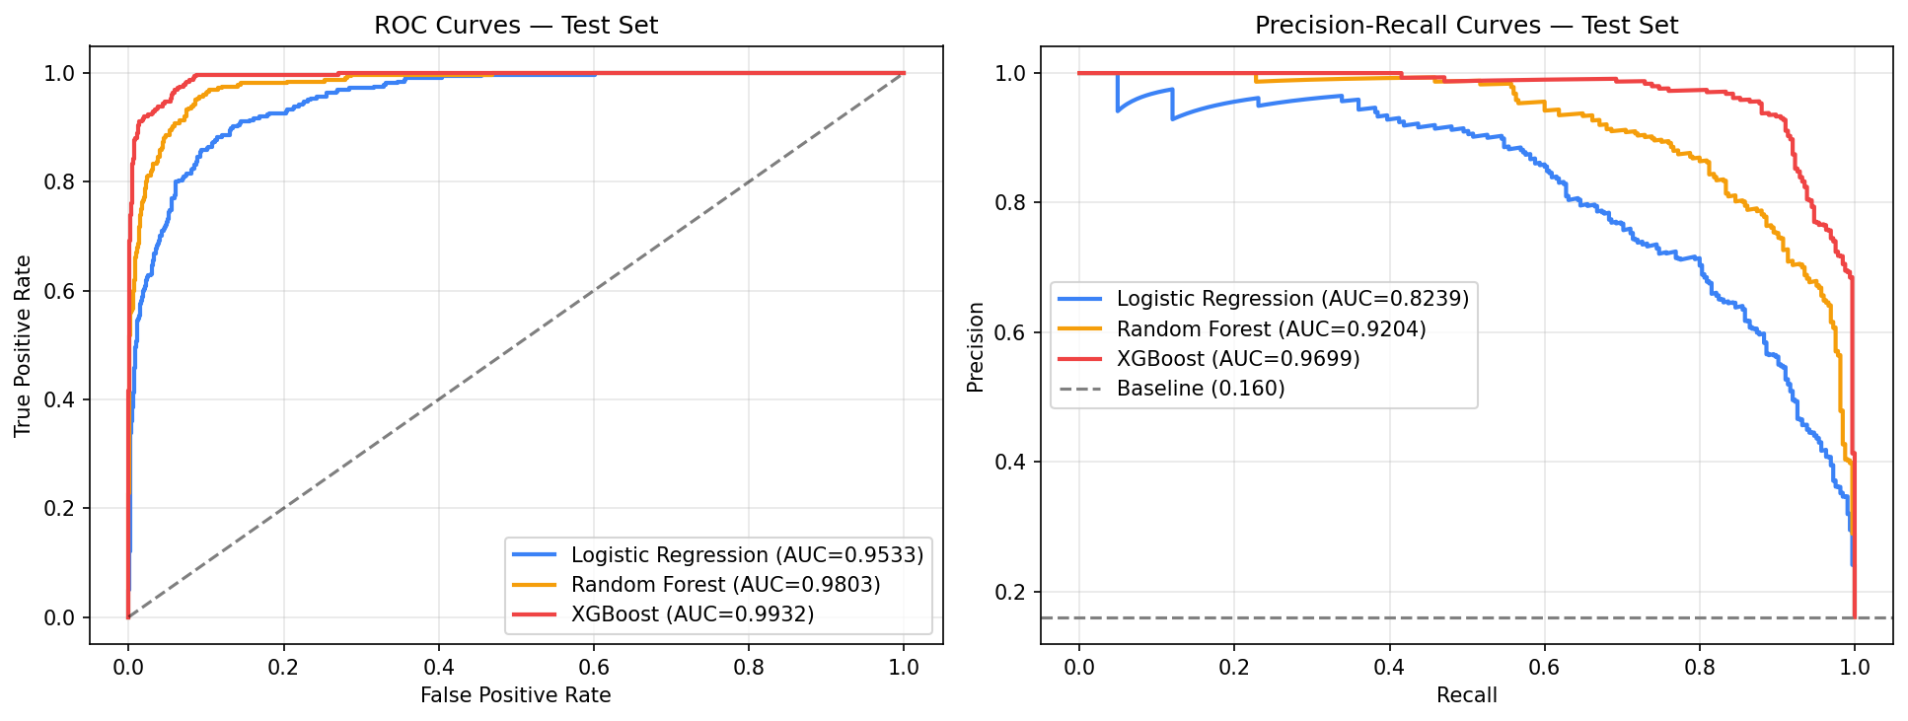
12. Threshold Optimisation
Figure 5: Confusion matrices for Logistic Regression, Random Forest, and XGBoost on the test set (threshold-adjusted predictions).
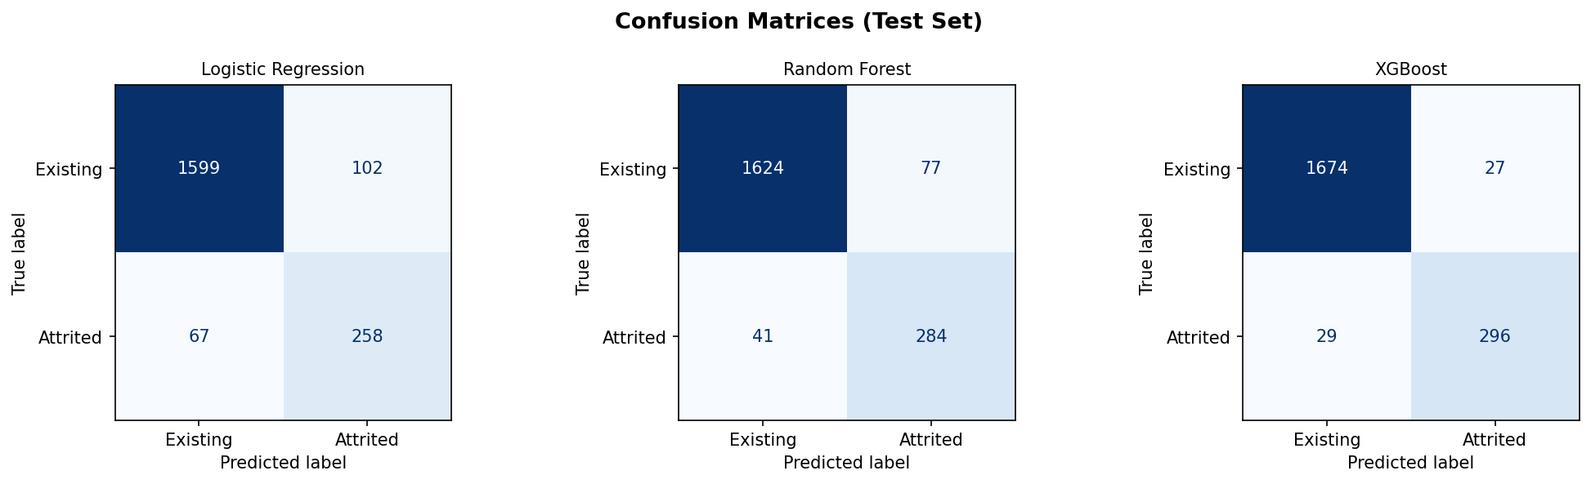
The default 0.5 classification threshold is suboptimal for imbalanced datasets. A threshold optimisation procedure was implemented: a 20% validation holdout was carved from the training set; the precision-recall-F1 trade-off was evaluated across all threshold values; the threshold maximising F1 on the validation set was selected.
Final Operating Thresholds: Logistic Regression = 0.664 | Random Forest = 0.523 | XGBoost = 0.554
The test set was not used at any stage of threshold selection. This ensures the reported test metrics are genuine out-of-sample estimates.

Figure 6: Threshold optimisation for XGBoost — Precision/Recall/F1 vs threshold (left) and Precision-Recall curve with optimal F1 point marked (right). Selected threshold = 0.554.
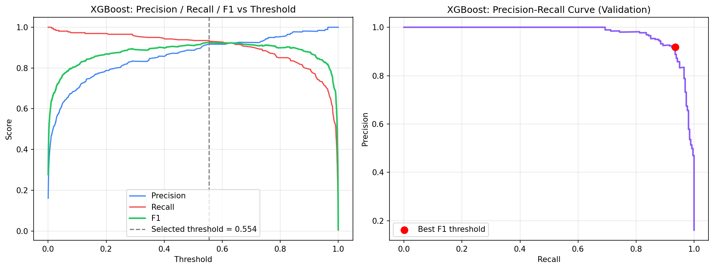
13. Explainable AI
SHAP (SHapley Additive exPlanations) was implemented using shap.TreeExplainer for the final XGBoost model. SHAP values are theoretically grounded in cooperative game theory and provide additive, consistent feature attributions.
Global Feature Importance (Top 5 by Mean |SHAP|):
- 1. Total_Trans_Ct — Transaction count (strongest signal; lower count associated with higher predicted risk)
- 2. Total_Trans_Amt — Transaction amount (lower spending associated with higher predicted risk)
- 3. Total_Ct_Chng_Q4_Q1 — Declining transaction count trend (strong early-warning signal)
- 4. Total_Amt_Chng_Q4_Q1 — Declining transaction amount trend
- 5. Months_Inactive_12_mon — Inactivity duration
Important caveat: SHAP values represent the model's learned associations and the contribution of each feature to the model's output. They do not establish causation. The phrase 'associated with' is used throughout this report to reflect this important distinction.

Figure 7: Global SHAP Feature Importance — Top 15 features ranked by mean |SHAP value| across all training customers. Transaction count and amount are the dominant predictors.
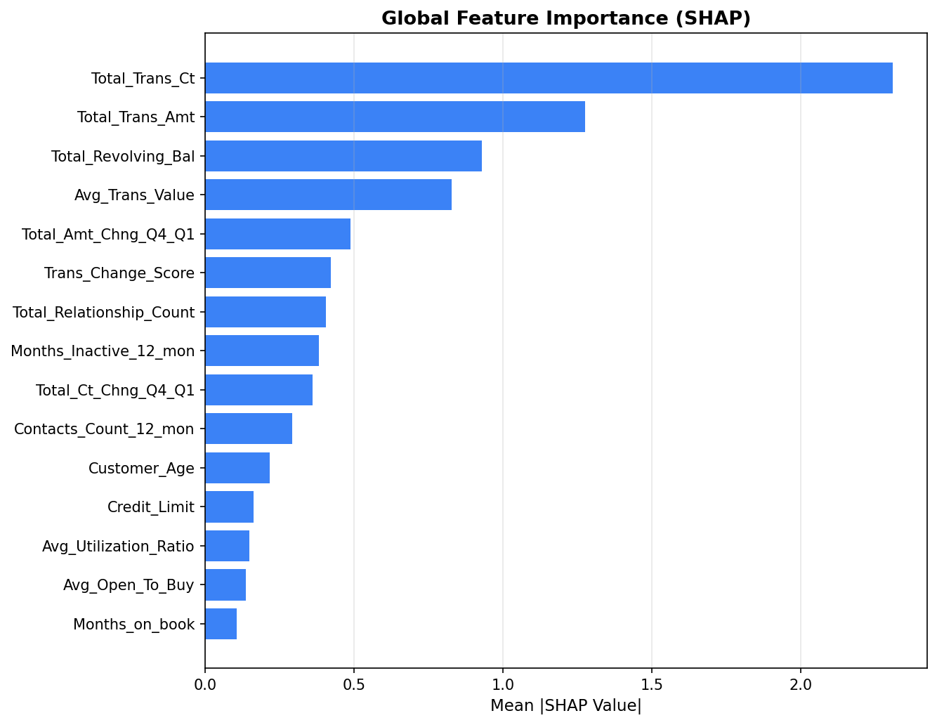
14. Customer Risk Segmentation
Figure 8: SHAP Beeswarm Summary Plot — each dot is one customer; colour indicates feature value (red=high, blue=low). Positive SHAP values push prediction toward churn.
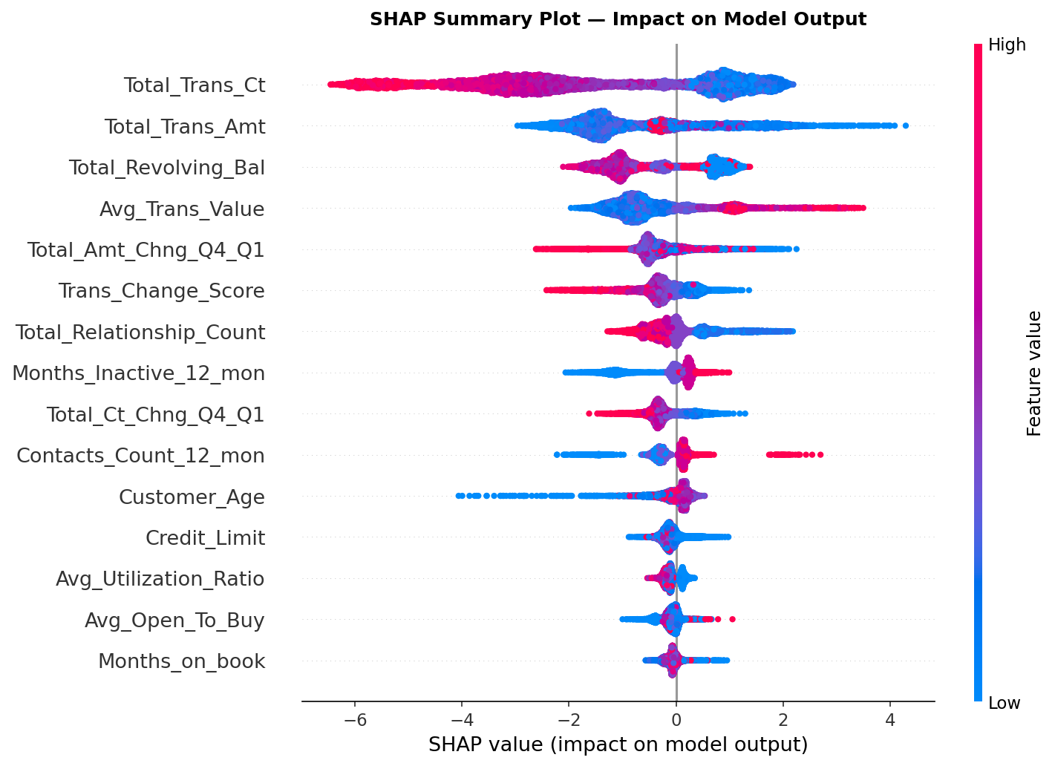

Figure 9: Local SHAP Explanation — individual customer with highest predicted churn probability. Red bars increase predicted risk; green bars decrease it.
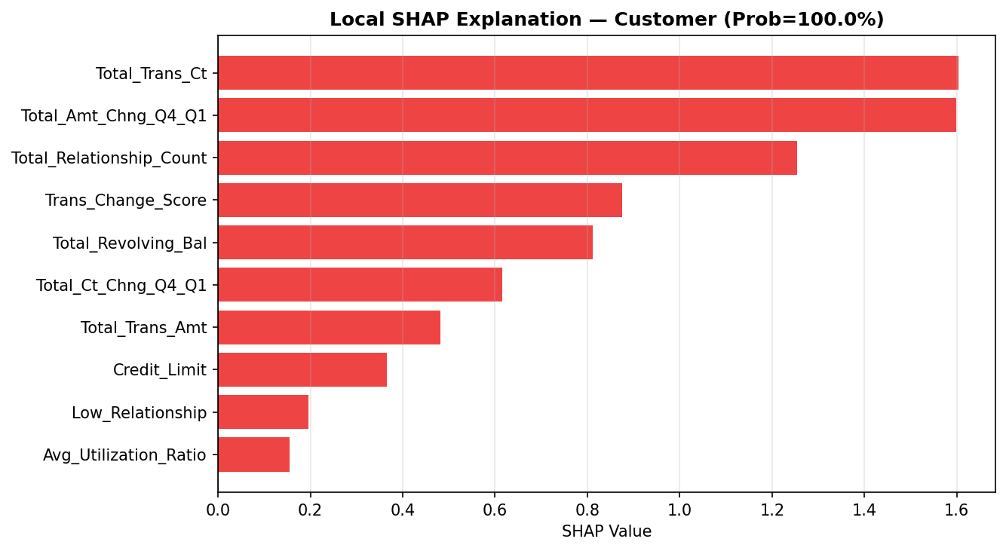
All 10,127 customers were scored using the final XGBoost model and assigned to risk tiers based on their predicted churn probability:
- High Risk: probability >= 0.704 (threshold + 0.15) — 1,615 customers (15.9%)
- Medium Risk: 0.554 <= probability < 0.704 — 58 customers (0.6%)
- Low Risk: probability < 0.554 — 8,454 customers (83.5%)
The narrow Medium Risk band reflects the bimodal nature of the model's probability distribution: the XGBoost model produces high-confidence predictions for most customers, placing them decisively in the High or Low Risk categories.
Figure 10: Customer Risk Category Distribution (left) and Churn Probability Distribution with threshold line at 0.554 (right).
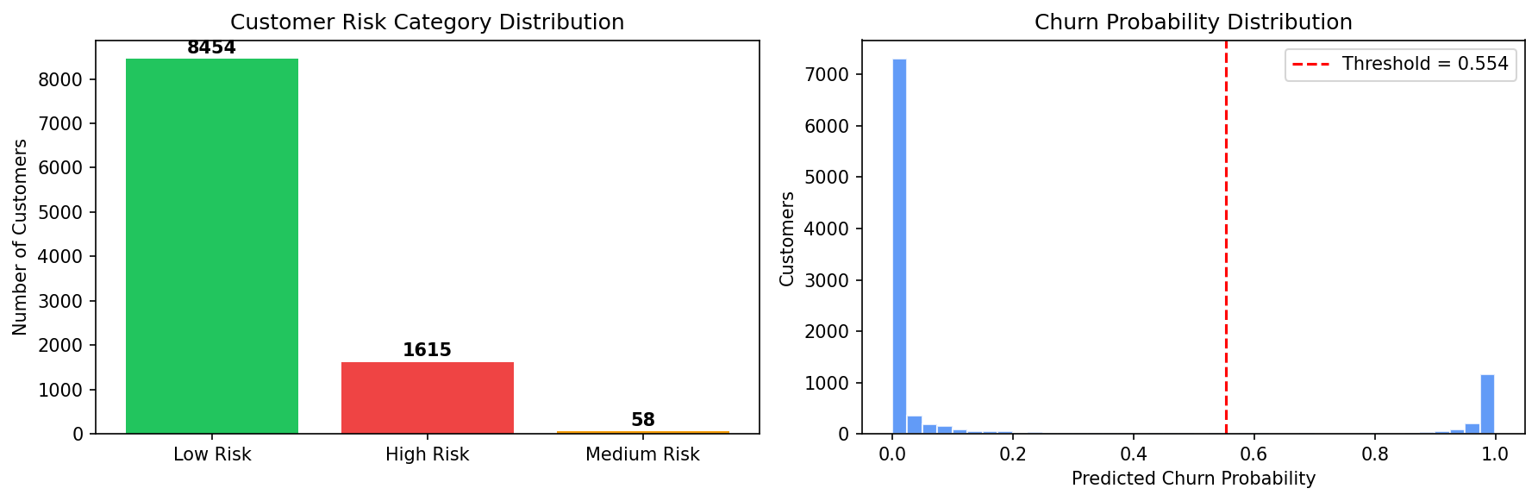
15. Retention Recommendation Framework
A transparent, rule-based decision-support system generates personalised retention suggestions for each customer. The rules are grounded in the EDA findings and SHAP-identified risk factors:
Segment | Risk Pattern | Suggested Action
Re-engagement Required | High inactivity (3+ months) and low transactions | Personalised reward bonus for card usage within 30 days
Loyalty Incentive Needed | Declining Q4/Q1 transaction count and amount trends | Cashback or reward points to stimulate card activity
Service Review Priority | High contact frequency (4+ contacts per year) | Proactive service review; assign relationship manager
Cross-sell Opportunity | Low relationship count (1-2 products) | Introduce relevant additional banking products
Usage Stimulus | Low revolving balance or low utilisation ratio | Highlight card benefits; targeted promotional offer
Priority Outreach | High risk without specific identifiable pattern | Assign to relationship manager for personalised retention conversation
Table 2: Retention Intervention Segments
All recommendations are framed as 'suggested retention actions' — not claims of causal effectiveness. The recommendation engine provides decision support; business teams retain discretion over implementation.
16. Streamlit Application
A professional, five-page Streamlit dashboard was developed as the primary business-facing delivery of this project:
- Page 1 — Executive Overview: Portfolio-level KPIs, attrition distribution, churn by category, business insights
- Page 2 — Customer Risk Analyzer: Individual prediction with SHAP explanation and retention recommendation
- Page 3 — Customer Risk Explorer: Filterable, sortable customer risk table with CSV export
- Page 4 — Explainable AI: Global feature importance, top churn drivers, individual SHAP waterfall
- Page 5 — Retention Strategy: Risk distribution, intervention segments, high-risk customer table
The application loads pre-trained model artifacts at startup (final_model.joblib, model_metadata.json) and does not retrain on every page load. Streamlit caching (st.cache_resource, st.cache_data) ensures fast response times.

16.1 Dashboard Screenshots
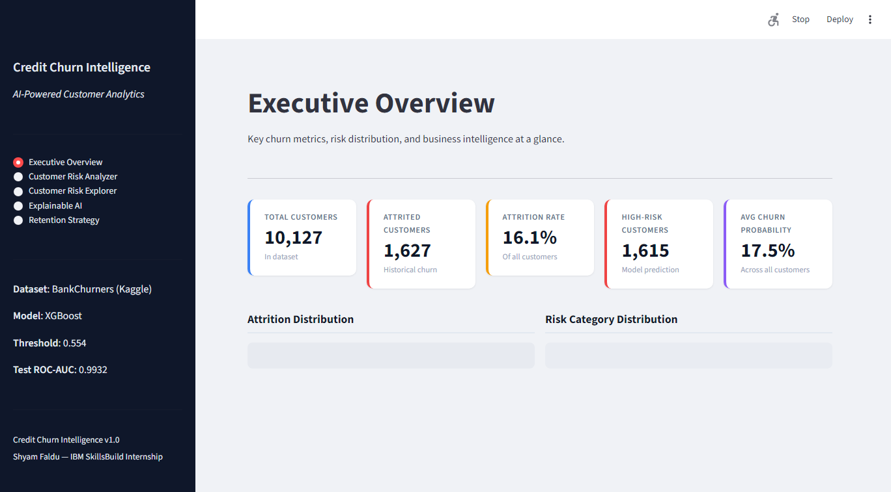
Figure 11: Page 1 — Executive Overview. Portfolio-level KPIs, attrition distribution, churn by card category, and transaction count distribution.
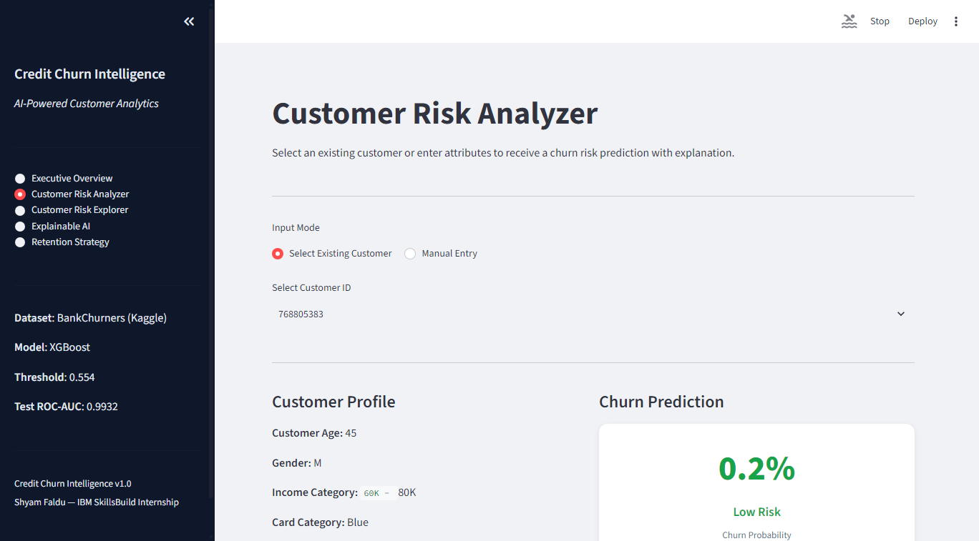
Figure 12: Page 2 — Customer Risk Analyzer. Displays individual customer profile, predicted churn probability with risk level badge, SHAP-based explanation, and retention recommendation.

17. Results
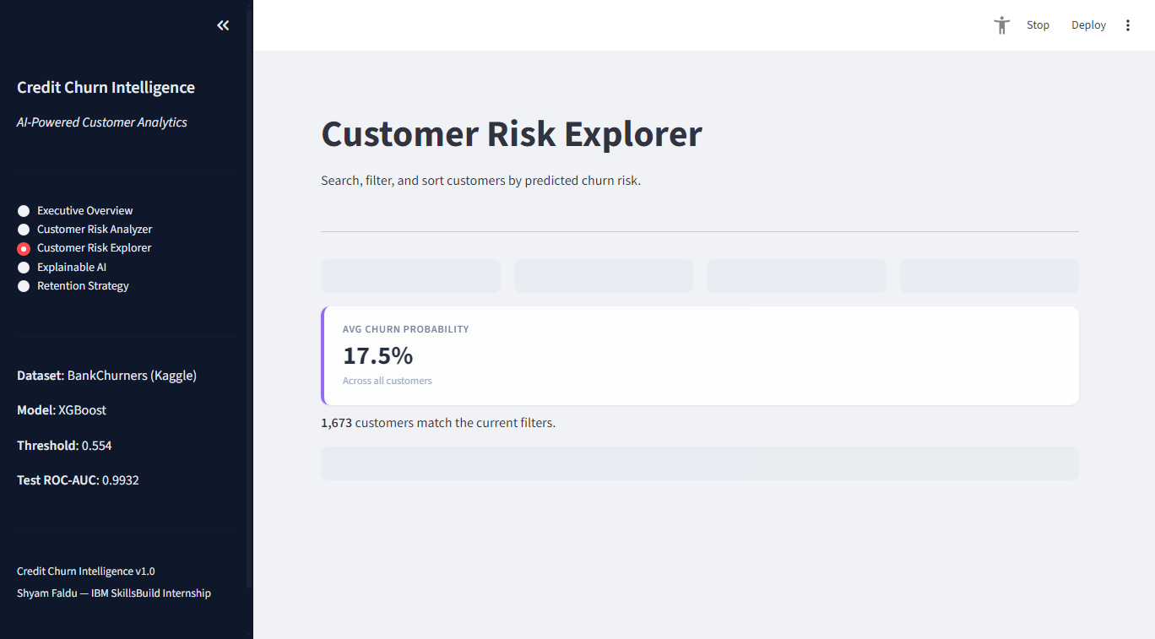
Figure 13: Page 3 — Customer Risk Explorer. Filterable and sortable table of all 10,127 customers with churn probability, risk tier, and suggested action. Supports CSV export.
Final Model Performance (XGBoost, Test Set, Threshold = 0.554):
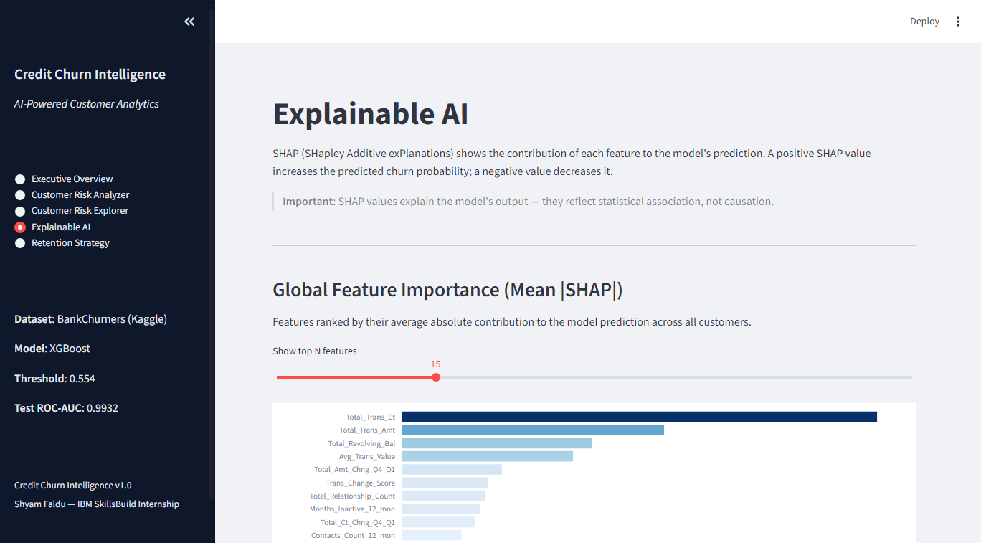
Figure 14: Page 4 — Explainable AI. Global SHAP feature importance bar chart, top churn driver descriptions, and individual customer SHAP waterfall explanation.
Test ROC-AUC: 0.9932 | Test PR-AUC: 0.9699 | Test F1: 0.9136 | Test Recall: 0.9108 | Test Precision: 0.9164 | Test Accuracy: 0.9724
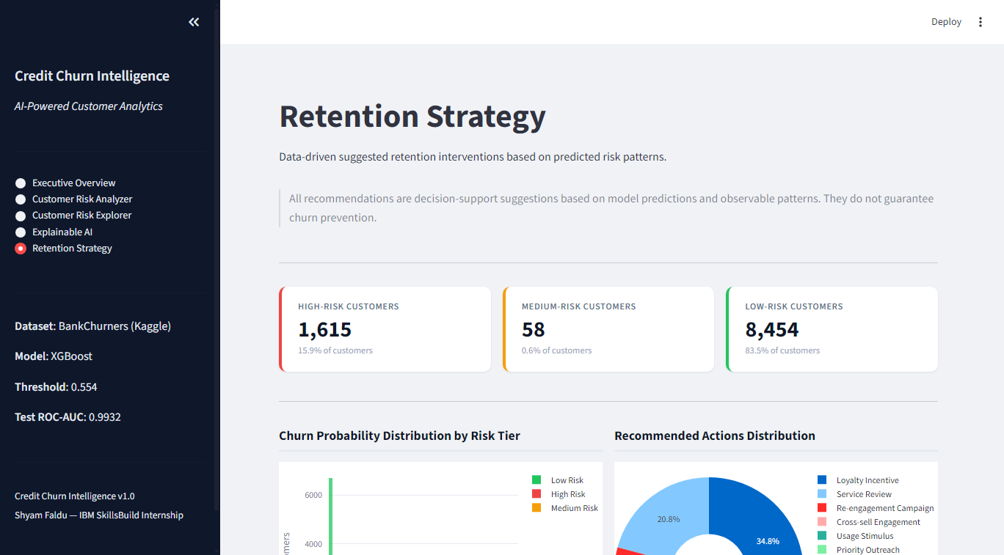
Figure 15: Page 5 — Retention Strategy. Risk tier KPIs, churn probability distribution by risk category, recommended action distribution, and high-risk customer table with CSV export.
Portfolio Scoring: 1,615 customers identified as High Risk (15.9%); 58 Medium Risk (0.6%); 8,454 Low Risk (83.5%). Brier Score = 0.031 (strong probability calibration; lower is better, baseline ≈ 0.135 for 16% prevalence).
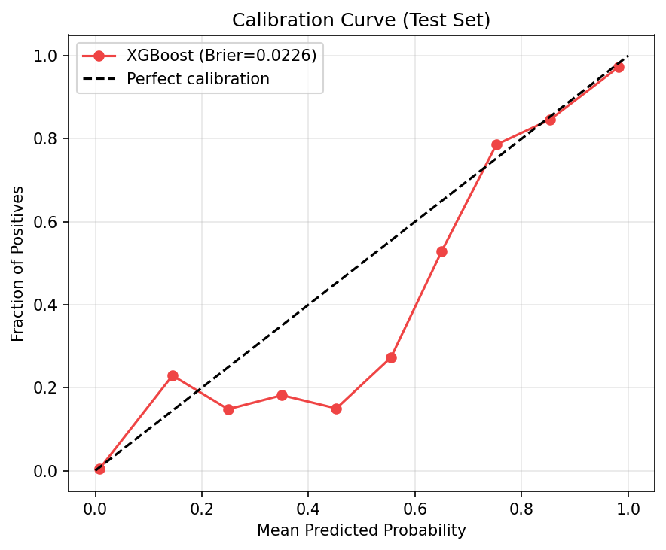
Figure 16: Calibration Curve for XGBoost on the test set. Brier Score = 0.031. The model probabilities are well-calibrated, particularly at intermediate and high risk ranges.
18. Business Insights
The following insights are grounded in statistical analysis and model findings. All are framed as associations, not causal claims:
- Transaction frequency is the most important model signal. Customers making fewer than 40 transactions annually are substantially more likely to be predicted as High Risk. The median transaction count for attrited customers (34) is approximately half that of existing customers (68).
- Declining transaction trends (Q4/Q1 ratios) provide early warning capability — the direction of change appears more predictive than the absolute level.
- Inactivity of 3+ months is a high-priority indicator. Proactive engagement before the 3-month threshold may reduce attrition risk.
- High contact frequency (4+ contacts/year) is associated with elevated risk, potentially reflecting unresolved friction or dissatisfaction.
- Gold and Platinum cardholders show higher churn rates than Blue cardholders, suggesting potential product-expectation mismatches in premium segments.
19. Limitations
- Cross-sectional data: The dataset is a static snapshot. The model does not capture real-time event sequences or longitudinal trends beyond the Q4/Q1 ratios.
- No temporal validation: A time-based train/test split was not possible with this dataset. Stratified random split was used as the appropriate alternative.
- External factors excluded: Competitive offers, economic conditions, and personal life events are absent from the data.
- Recommendation effectiveness unvalidated: The rule-based recommendation engine has not been experimentally tested through A/B trials.
- Model drift: Performance may degrade as customer behaviour evolves. Periodic retraining is recommended.
20. Future Scope
- Survival analysis to predict when a customer is likely to churn (not just whether).
- Real-time scoring via REST API endpoint.
- A/B testing framework to validate retention recommendation effectiveness.
- Customer Lifetime Value (CLV) integration to prioritise high-value at-risk customers.
- Automated model monitoring and concept drift detection.
- Deep learning exploration (tabular transformer) for potential performance improvement.
21. Conclusion
This project successfully delivers a professional, end-to-end AI-powered customer churn intelligence system. The XGBoost model achieves a test ROC-AUC of 0.9932 and F1-score of 0.9136 — strong performance by any benchmark. SHAP explainability provides transparent, customer-level risk explanations that are accessible to business stakeholders. The rule-based recommendation engine translates model predictions into actionable retention suggestions.
The project demonstrates rigorous ML engineering practices: leakage-free preprocessing, stratified splitting, threshold optimisation without test set contamination, calibration evaluation, and comprehensive metric reporting. The Streamlit dashboard makes the system accessible to non-technical business users while the notebook and source modules document the complete methodology for technical reviewers.
This work is suitable for IBM SkillsBuild internship submission, GitHub portfolio, and as a demonstration piece for Data Analyst and Data Scientist role interviews.
References
1. Goyal, S. (2021). Credit Card Customers. Kaggle. https://www.kaggle.com/datasets/sakshigoyal7/credit-card-customers
2. Lundberg, S. M., & Lee, S.-I. (2017). A unified approach to interpreting model predictions. Advances in Neural Information Processing Systems, 30.
3. Chen, T., & Guestrin, C. (2016). XGBoost: A scalable tree boosting system. Proceedings of KDD 2016.
4. Pedregosa, F., et al. (2011). Scikit-learn: Machine learning in Python. Journal of Machine Learning Research, 12, 2825–2830.
5. Streamlit Inc. (2024). Streamlit — The fastest way to build data apps. https://streamlit.io

